**Focus your search changes on homescreen**

Swap the Virtual On Demand and Focus your Search button position.

Change Focus Your Search copy to ‘Subject Search’.

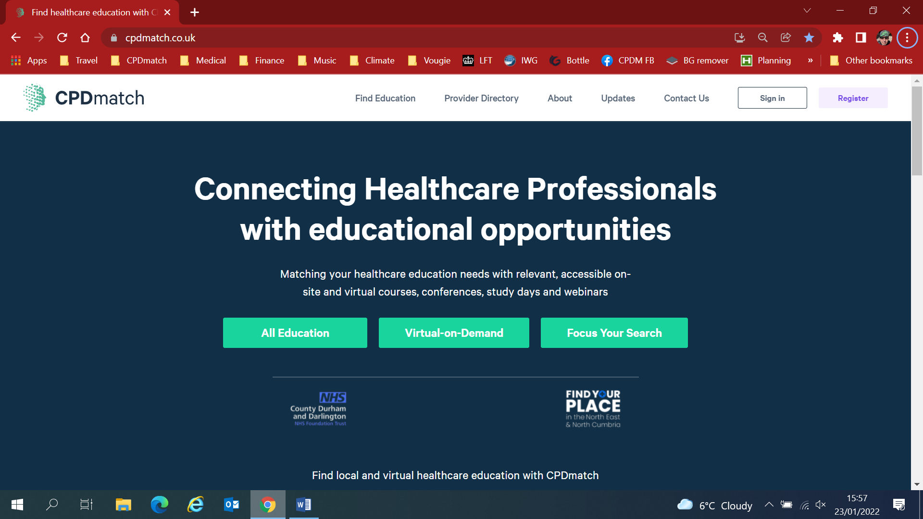

Subject search to open or be a drop-down list below the button which can be scrolled through and not open the side-window as it does now:

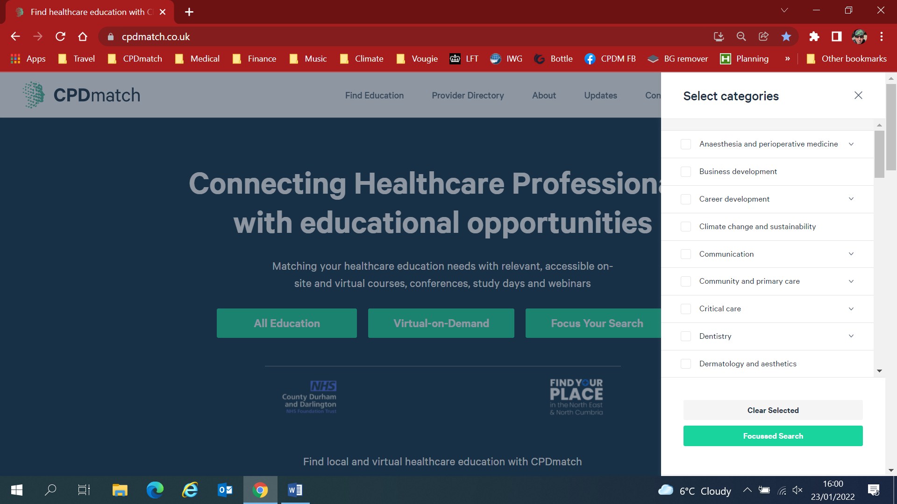

The list must only be the ‘top-level’ subject categories and not be expandable. It should NOT have checkboxes and the mouse pointer / scroll wheel should be use to select one category. Note button shown below would be in middle in this new design so loads of horizontal space for the top-level category names.



Anaesthesia and peri-operative medicine

Business development

Career development

Climate change and sustainability

Communication

Community and primary care

Critical cared

Dentistry

When a top-level category is selected, the site applies this and moves onto the FIND EDUCATION page (with the appropriate one top-level category selected in CATEGORIES (arrowed).

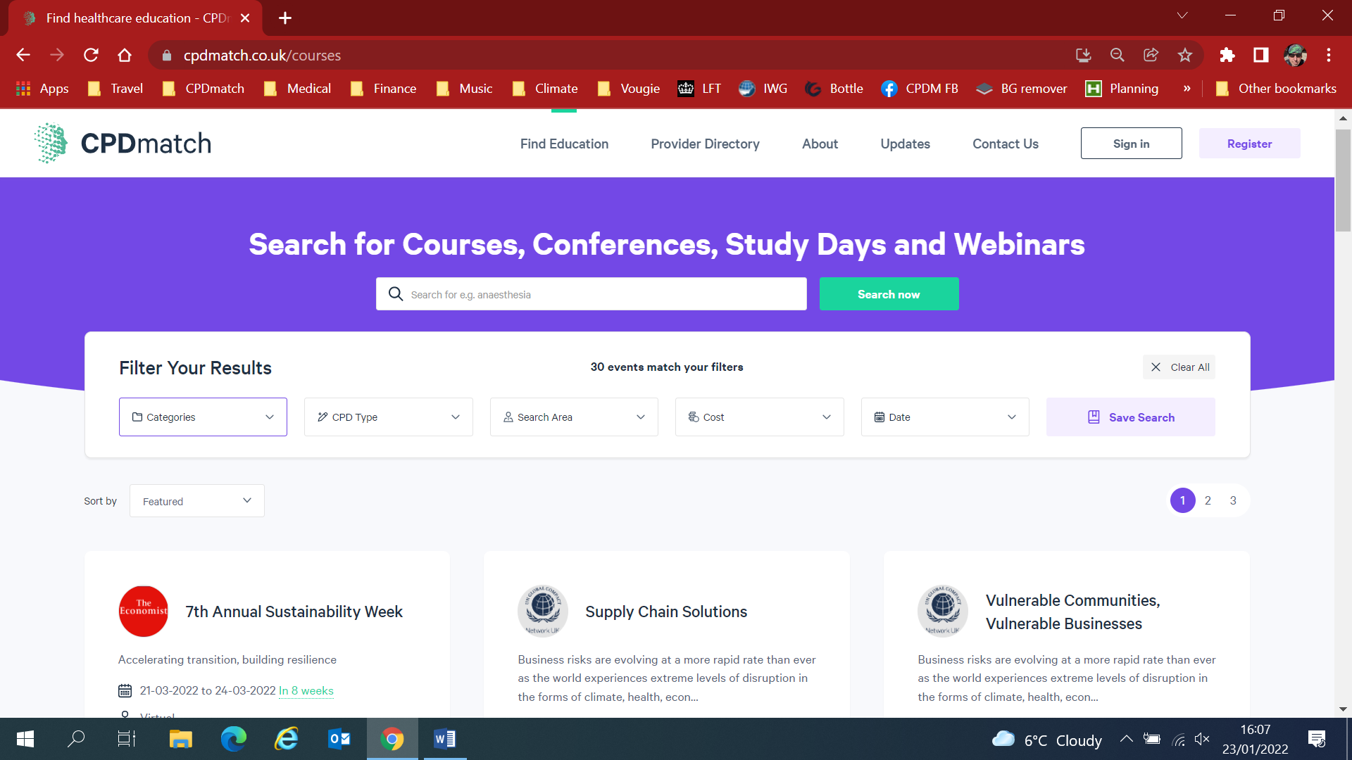

Hopefully this will all work well on the mobile site too.